Latin America Revolutions Graphic Organizer

Zapatistas
In 1994 a rebellion of Native Americans began in the southern Mexican state of Chiapas. They named themselves after Emiliano Zapata an indian farmer and hero of the 1910 Mexican Revolution. They protested the poverty faced by Native Americans and farmers. They began their revolt after NAFTA was signed because cheap corn and other food started coming to Mexico They took over 4 towns in Chiapas 100 people were killed before a cease fire.
Mexico City Independence
Miguel Hidalgo was a Catholic priest in the town of Delores he believed in enlightenment ideas like social reform, freeing the slaves and returning the land to the farmers. When France invaded Spain he saw his chance to call for independence “the Cry of Delores” he led people to Mexico City but they were no match for the soldiers. Hidalgo was capture and killed but the revolution lived on.
Cuban Revolution
The US helped Cuba become independent in Spanish American War. In 1950s Fulgencio Batista made himself dictator of Cuba. Many people were unhappy with his rule because there were too many poor people. Fidel Castro led a rebellion and named himself dictator and organized a communist government

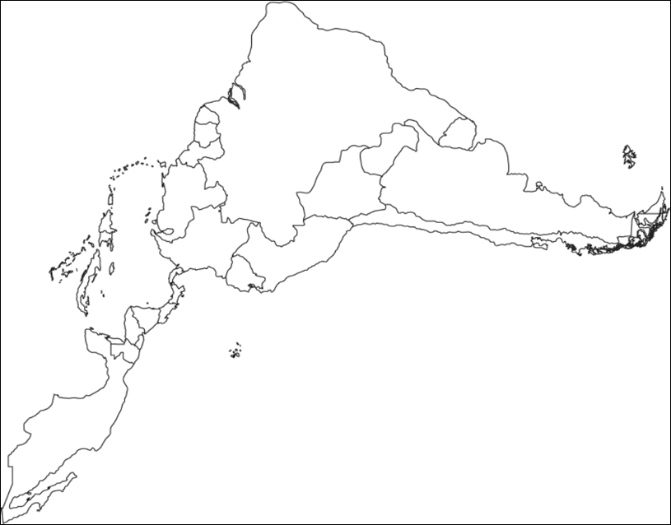
South American Revolutions
Simon Bolivar was from a wealthy crillo family from Venezuela who believed that it should free itself from Spain. He fought for 15 years to free a number of South American countries such as Columbia, Panama, Venezuela & Ecuador which made up Gran Columbia and also freed Peru and Bolivia

Simon Bolivar is known as The Liberator or the George Washington of South America
Slave Rebellion in Haiti
The French colony in St. Domingue (now Haiti) forced its slaves to work long hours in terrible working conditions on Sugar and Coffee plantations. A former slave named Toussaint L’Ouverture led the people to victory. He then fought off the Spanish and British who tried taking over. He began to rebuild the country guaranteeing housing and medical care. The French then tricked L’Ouverture to coming to a meeting where they put him in chains and shipped him to France where he died in prison.

.

